**Confusion Matrix Results:**

**Calculation Code:**

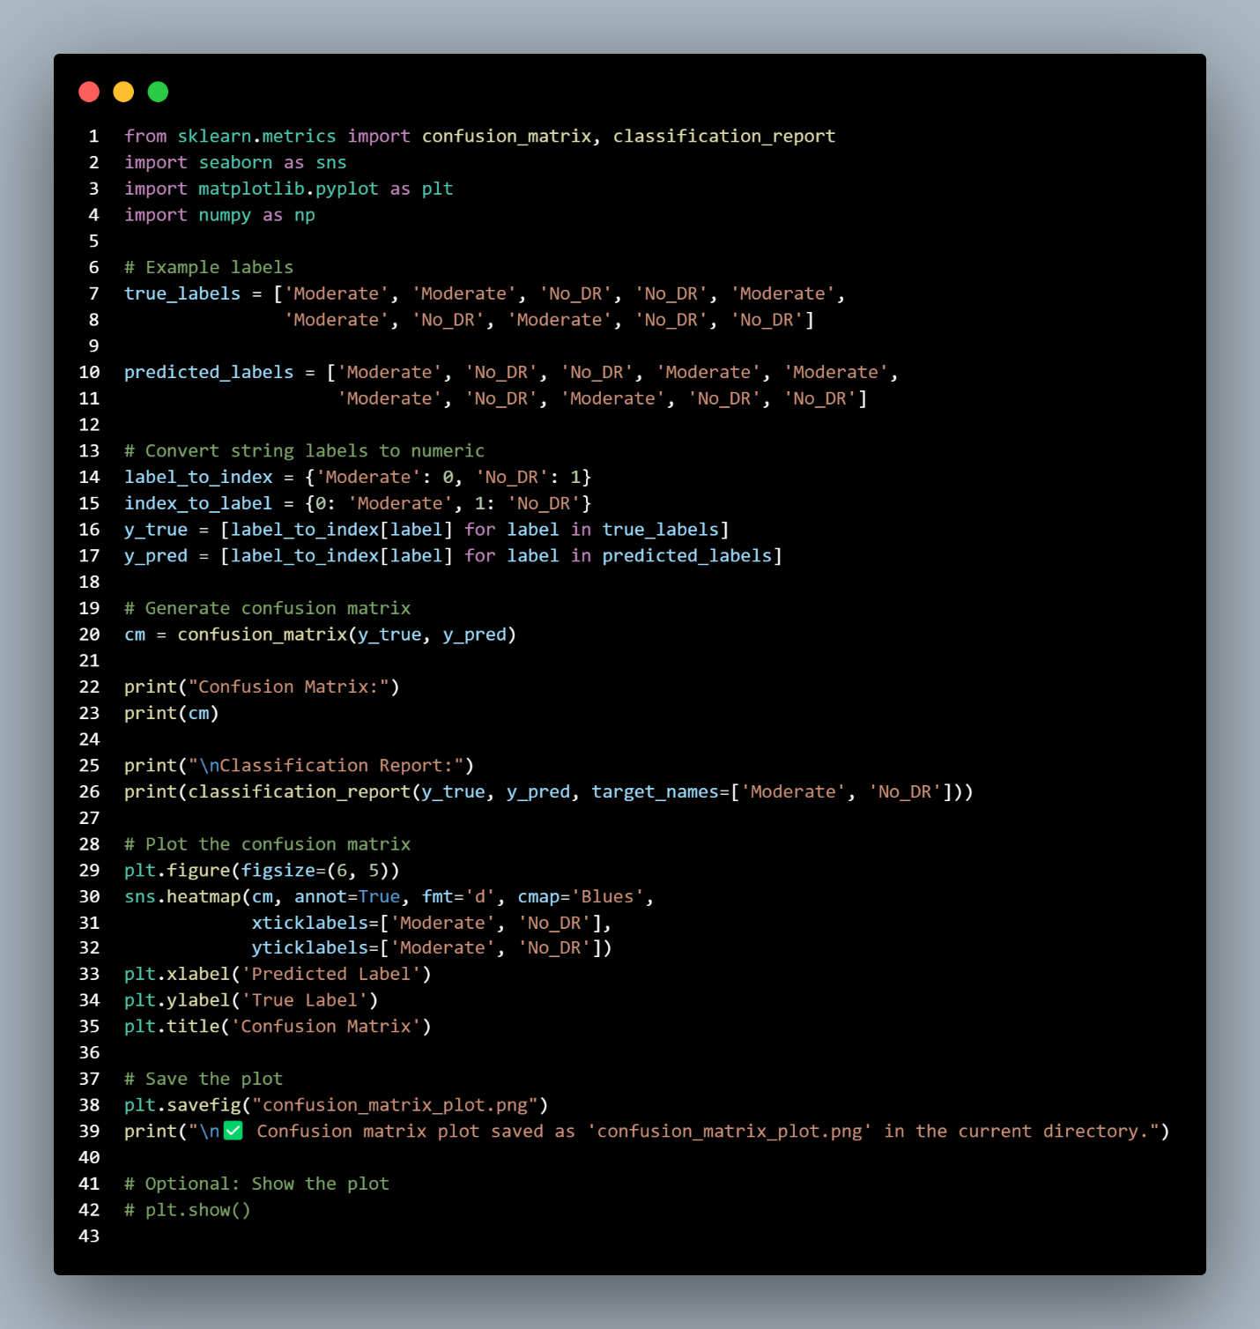

**Results:**

Confusion Matrix:

[[4 1]

[1 4]]

**Classification Report:**

|  |  |  |  |  |
| --- | --- | --- | --- | --- |
|  | precision | recall | f1-score | support |
| Moderate | 0.80 | 0.80 | 0.80 | 5 |
| No_DR | 0.80 | 0.80 | 0.80 | 5 |

|  |  |  |  |  |
| --- | --- | --- | --- | --- |
|  | precision | recall | f1-score | support |
| accuracy | 0.80 | 0.80 | 0.80 | 10 |
| macro avg | 0.80 | 0.80 | 0.80 | 10 |
| **weighted avg** | 0.80 | 0.80 | 0.80 | **10** |

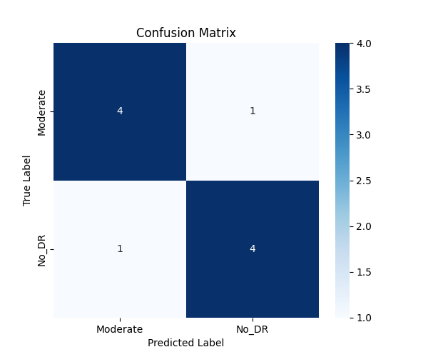

**Precision**

Moderate: 0.80 → Among all images predicted as Moderate, 80% were actually Moderate.

No_DR: 0.80 → Among all images predicted as No_DR, 80% were actually No_DR.

**Recall**

Moderate: 0.80 → Among all true Moderate images, 80% were correctly predicted.

No_DR: 0.80 → Among all true No_DR images, 80% were correctly predicted.

**F1-score**

Harmonic mean of precision and recall; combines them into a single score.

**Accuracy**

Overall correctness: (4 + 4) / 10 = 0.80 → 80% of images were classified correctly.